Rats
- Dread Pyrate
- Member

- 1,095 posts
- Gender:Male
- Location:Whitewater WI.
- Interests:Theft, brigandry, pilfering and bad grammar
Posted September 26, 2006 · Report post
Ok, since we're going for the correct look and plastic sporks won't work. (God I luv a good spork!) so what are correct eating goods?
Pewter goods?
clay works?
Wooden tankards?
Cast iron forks??
Rats

Patrick Hand
- The sailor's sailor
- Moderator

- 6,100 posts
- Gender:Male
- Location:TH' Mountains of Central California
- Interests:I like wierdness... Klingon, Pyrate..... and even..... gasp.... Renn Faires...... (Baseball and tractor pulls I'd have to think about.... could be wierd or Not,,,,)
Posted September 26, 2006 · Report post
I haven't realy looked very hard for one..... but there were a buncha pewter spoons recovered from the Whydah with holes drilled in the handle to hang them...... with a little looking I'm sure I could find a good copy of one.....
Right now I use a pewter plate, horn spoon, belt knife, pewter tankard or tin cup (OK.... so the tin cup isn't right..... but I can cook in it..... I'll replace it with a copper one kinda soon......)
But there are some (well a few) good pictures in the book "Expedition Whydah" showing the spoons and plates (and some of the initials that were carved into them.......)

Rumba Rue
- Immortal Pyrate
- Member

- 7,270 posts
- Gender:Female
Posted September 27, 2006 · Report post
Hit the Thrift stores Rats!
You can find just practically everything you'd ever need!

Cpt. Alva
- Ship's Master
- Member

- 155 posts
- Location:The Skanktuary
- Interests:Monkeys, Ninjas, Pirates, Mutants, Videogames, Clowns, Robots, Superheroes, Music, Zombies, Dinosaurs, Cowboys, Movies, Art, and everything in between
Posted September 28, 2006 · Report post
I have the last solid-bottomed "Horn Mug" on earth, it would seem.....(Not really, but it seems that way, I rarely see my style anymore)
what I mean is this......
This is my mug:

This is the BOTTOM of my mug

I bought it about a decade ago......it's a great mug, and I love it......but shortly after I bought it, they disappeared from the market.....but only temporarily.....
the reason, was because they re-tooled the molds, because the design used too much pewter......so they hollowed it, and all new ones look like this:

I love my big, heavy, solid-bottomed mug......it's nice to know that if I ever need to kill a man with a cup, I have one equal to the task!

blackjohn
- Iron Age Hero Lost at Sea
- 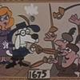
- Member

- 3,745 posts
- Gender:Male
- Location:Columbia, Md
- Interests:Stuff... and junk.
Posted September 28, 2006 · Report post
Can that mug be be dated to our period?

blackjohn
- Iron Age Hero Lost at Sea
- Member

- 3,745 posts
- Gender:Male
- Location:Columbia, Md
- Interests:Stuff... and junk.
Posted September 28, 2006 · Report post
Rats said:
Ok, since we're going for the correct look and plastic sporks won't work. (God I luv a good spork!) so what are correct eating goods?
Pewter goods?
clay works?
Wooden tankards?
Cast iron forks??
Rats
Both of my sons think sporks are the greatest things. I'd agree, if it weren't for the foon.
Trifid spoons...
http://www.argentum-theleopard.com/archive.cfm

blackjohn
- Iron Age Hero Lost at Sea
- Member

- 3,745 posts
- Gender:Male
- Location:Columbia, Md
- Interests:Stuff... and junk.
Posted September 28, 2006 · Report post
Bellarmine jugs...
http://www1.bellarmine.edu/strobert/jugs/jugs1.asp

blackjohn
- Iron Age Hero Lost at Sea
- Member

- 3,745 posts
- Gender:Male
- Location:Columbia, Md
- Interests:Stuff... and junk.
Posted September 28, 2006 · Report post
Your one stop shop for all your clayware needs...
http://www.juliasmith.com/historicpottery/
And who said the 17thC/18thC was drab... good lord... what wonderful colors... if you ever find yourself on Cape Cod, in Sandwich, make sure you visit the oldest house there. It's from the mid-to-late 1600s, and the color scheme is out of this world.

Capt. Sterling
- Sticky Fingers Sterling Needs a New Hat
- Member

- 10,302 posts
- Gender:Pyrate Hunter
- Location:here
- Interests:Killing pirates, haven't met one yet worth keeping alive....
Posted September 28, 2006 · Report post
http://goosebay-workshops.com/CUPS-CANTEENS
http://www.tuckahoetradingco.com/
watch your dates!

blackjohn
- Iron Age Hero Lost at Sea
- Member

- 3,745 posts
- Gender:Male
- Location:Columbia, Md
- Interests:Stuff... and junk.
Posted September 28, 2006 · Report post
Tuckahoe... yep, Tom Apple's stuff rocks!
Pewter...
http://www.pewterreplicas.co.uk/
The Goose bay dude... his stuff rocks too, I mean big time, though I recall him as sometimes taking liberties with history. Of course, I'm old, and my brain doesn't quite remember things like it used to...

jessie k.
- Ship's Master
- Member

- 180 posts
- Location:Midwestern US
- Interests:Oh, everything. :D But to list a few...pirates, medieval history, horses, plants and their practical uses, books (all of them), archaeology, people, canoeing, camping, FIRE, etc.
Posted September 28, 2006 · Report post
"I have the last solid-bottomed "Horn Mug" on earth, it would seem"
Not the last...I know my reenacting group has one or two in with it's loaner gear. Look exactly like that; I think we have one solid bottomed one, and maybe one hollow one.

Fox
- Old Twillian
- Moderator

- 2,564 posts
- Gender:Male
- Location:Beautiful lush Devon, England
- Interests:Nautical history of the 16-18th centuries and living history based thereon.
Shooting pirates.
Posted September 28, 2006 · Report post
A hollow bottomed mug? What will you colonials come up with next?
Is it for recovering alcoholics?

Gentleman of Fortune
- Dread Pyrate
- Member

- 1,456 posts
- Gender:Male
- Location:Germany... Franconia (northern Bavaria)
- Interests:I *used* to be an environmental scientist, until I married a DoDDs teacher in 1997. Since then, I have been living in, and traveling around, Europe (First the UK, now Germany).
My hobbies are all the "usual suspects" for those interested in re-enacting and Golden Age of Piracy stuff.... but I have drifted away from the pirate scene as my location and young family don't allow for any more than "virtual" pirate participation. Besides Piracy, I am into Reverend Guitars and Vintage Corvettes.
Posted September 28, 2006 · Report post
*snicker*

CrazyCholeBlack
- Scourge o' the 7 Seas
- Member

- 1,578 posts
- Gender:Female
- Location:Illinois
- Interests:Everything! Historic clothing, sewing, fabric dying, cooking, mead, ale, astronomy, celestial navigation, reading, music, film making, blogging & pillaging the internet for visual inspirations.
Posted September 28, 2006 · Report post
Westmoore Pottery has pottery & hand blown glass that is amazing.
http://www.westmoorepottery.com/index.htm
I'm lusting after their green 1670's beer glass myself.

jessie k.
- Ship's Master
- Member

- 180 posts
- Location:Midwestern US
- Interests:Oh, everything. :D But to list a few...pirates, medieval history, horses, plants and their practical uses, books (all of them), archaeology, people, canoeing, camping, FIRE, etc.
Posted September 28, 2006 · Report post
Quote
A hollow bottomed mug? What will you colonials come up with next?
I dunno, maybe public toilets that aren't coin operated? :)

kass
- Scourge o' the 7 Seas
- Member

- 1,526 posts
- Gender:Male
- Location:Easton, Pennsylvania
- Interests:Historical Clothing from the 14th through 18th centuries. Getting all the niggling details right. Dressing up and having fun with my similarly-obsessed friends. :)
Posted September 28, 2006 · Report post
Good one Jessie!

Capt. Sterling
- Sticky Fingers Sterling Needs a New Hat
- Member

- 10,302 posts
- Gender:Pyrate Hunter
- Location:here
- Interests:Killing pirates, haven't met one yet worth keeping alive....
Posted September 28, 2006 · Report post
Foxe said:
A hollow bottomed mug? What will you colonials come up with next?
Is it for recovering alcoholics?

Capt. Sterling
- Sticky Fingers Sterling Needs a New Hat
- Member

- 10,302 posts
- Gender:Pyrate Hunter
- Location:here
- Interests:Killing pirates, haven't met one yet worth keeping alive....
Posted September 28, 2006 · Report post
jessie k. said:
Quote
A hollow bottomed mug? What will you colonials come up with next?
I dunno, maybe public toilets that aren't coin operated? :)
OH we used to have those too!

Captain Tightpants
- Deck Hand
- Member

- 50 posts
- Location:Easton, PA, USA
Posted September 29, 2006 · Report post
blackjohn said:
Trifid spoons...
http://www.argentum-theleopard.com/archive.cfm
I cannot be the only person who saw something completely different when he read "Trifid."

blackjohn
- Iron Age Hero Lost at Sea
- Member

- 3,745 posts
- Gender:Male
- Location:Columbia, Md
- Interests:Stuff... and junk.
Posted September 29, 2006 · Report post
Cpt. Alva said:
blackjohn said:
Can that mug be be dated to our period?
No Clue to be honest, but It's my drinking mug, hell or high water.....
if I'm at an event, it's tied to me haversack........if it don't go, I don't go........
So, what you are saying is you haven't documented it to our period, and don't care. Gotcha.

CrazyCholeBlack
- Scourge o' the 7 Seas
- Member

- 1,578 posts
- Gender:Female
- Location:Illinois
- Interests:Everything! Historic clothing, sewing, fabric dying, cooking, mead, ale, astronomy, celestial navigation, reading, music, film making, blogging & pillaging the internet for visual inspirations.
Posted October 1, 2006 · Report post
My dear Mr. Alva. That is the thing that I have learned right quickly whilst being here. Tis not like the legal system. Tis safer to assume something is not period until proven otherwise.
For those of us searching in the thrifts, what stylistic traits should eating utensils during the GAoP have? Certainly not glass bottomed tankards, but what else? Riveted vs. welded handles? Have forks settled into the common 3 prong style?
My thanks to the "particular" sort.

Captain Tightpants
- Deck Hand
- Member

- 50 posts
- Location:Easton, PA, USA
Posted October 1, 2006 · Report post
"Chloe" said:
For those of us searching in the thrifts, what stylistic traits should eating utensils during the GAoP have? Certainly not glass bottomed tankards, but what else? Riveted vs. welded handles? Have forks settled into the common 3 prong style?
Keep in mind the following are my opinions only.
First, a good sturdy sharp knife is required. In a pinch, it can be used as a fork. Spoons for the not-ship's-officer are more than probably horn, wood, or unadorned pewter. By 1700, forks were often found with three tines, so worry not. Look for trifid or "Dog Nose" patterns on the handles if you're looking for actual silverware; otherwise, riveted handles of bone or wood will do you fine.
Bowls and the like should be wheel-thrown pottery; Delftware and Staffordshire salt-glazed stoneware are most appropriate. For plates, go metal, like brass, tin, or pewter. Wooden (or "treen") ware had been going out of fashion in England since the 1640s. By the end of the century, even the poorest households in rural areas were replacing treen ware with stoneware, brass, and pewter.
Good luck, and let us know how your search progresses!

kass
- Scourge o' the 7 Seas
- Member

- 1,526 posts
- Gender:Male
- Location:Easton, Pennsylvania
- Interests:Historical Clothing from the 14th through 18th centuries. Getting all the niggling details right. Dressing up and having fun with my similarly-obsessed friends. :)
Posted October 1, 2006 · Report post
Those of you who have been following this thread may notice that it has changed significantly in the last few minutes. That's because I got out my moderator stick and started swinging.
This forum, by its own definition, is "Academic talk on maritime history, research, & interesting info." It is the place for posting research, enquiring about other people's research, asking questions about things appropriate to the Golden Age of Piracy, and related subjects.
It is NOT the place for people to post "Well this is what I use and those who don't like it can go blow!" And I will NOT tolerate such posts.
I will also not tolerate slams against people who choose period appropriate accoutrements for their kit. I will hear no whining about "elitism" "naziism" and other such rot. We don't come into PIRATE POP and tell you that nothing you like is period appropriate. So if you're not interested in historical things, don't come to this forum. If you don't like what we're talking about, don't post here!
In other words NO TROLLING!
I will delete your posts. All your posts. And if you think you can push me further, I'll have you bounced. Understand?
Now play nice.

Rats
- Dread Pyrate
- Member

- 1,095 posts
- Gender:Male
- Location:Whitewater WI.
- Interests:Theft, brigandry, pilfering and bad grammar
Posted October 1, 2006 · Report post
Here's to you darlin!
If you ever get tired of yer own prosperous business, we're always looking for toughies in the Shire Reaves!
Can't we all just get along, or at least drunk!!
Take care!
Rats!

kass
- Scourge o' the 7 Seas
- Member

- 1,526 posts
- Gender:Male
- Location:Easton, Pennsylvania
- Interests:Historical Clothing from the 14th through 18th centuries. Getting all the niggling details right. Dressing up and having fun with my similarly-obsessed friends. :)
Posted October 1, 2006 · Report post
Well, I'd sure like to buy Tightpants and Alva a round!
Guys? You in? Period-appropriate mugs not required! :)

Cpt. Alva
- Ship's Master
- Member

- 155 posts
- Location:The Skanktuary
- Interests:Monkeys, Ninjas, Pirates, Mutants, Videogames, Clowns, Robots, Superheroes, Music, Zombies, Dinosaurs, Cowboys, Movies, Art, and everything in between
Posted October 1, 2006 · Report post
in researching Early American, and British Pewter, one thing has stood out to me.....
the shape......most American Tankards, and Mugs were STRAIGHT SIDED, with very little decoration......so far, my design is right out.......fair enough.....
Most British ones, were pear-shaped........probably to go along with matching teapots........

kass
- Scourge o' the 7 Seas
- Member

- 1,526 posts
- Gender:Male
- Location:Easton, Pennsylvania
- Interests:Historical Clothing from the 14th through 18th centuries. Getting all the niggling details right. Dressing up and having fun with my similarly-obsessed friends. :)
Posted October 1, 2006 · Report post
Cool! Got any pictures to share, Captain, so Chole can go shopping?

CrazyCholeBlack
- Scourge o' the 7 Seas
- Member

- 1,578 posts
- Gender:Female
- Location:Illinois
- Interests:Everything! Historic clothing, sewing, fabric dying, cooking, mead, ale, astronomy, celestial navigation, reading, music, film making, blogging & pillaging the internet for visual inspirations.
Posted October 1, 2006 · Report post
Thank you very much for the guidelines Mr. Fairfax, they will serve me well whilst on the hunt. I can not be the only person who becomes a bit overwhelmed at the thrifts.

kass
- Scourge o' the 7 Seas
- Member

- 1,526 posts
- Gender:Male
- Location:Easton, Pennsylvania
- Interests:Historical Clothing from the 14th through 18th centuries. Getting all the niggling details right. Dressing up and having fun with my similarly-obsessed friends. :)
Posted October 1, 2006 · Report post
Oh, you're sure not, Chole! I sometimes take a notebook with printouts of period still life paintings so I can check 'em. None of my pewter ewers are perfect, but one was free and the other two were £20 each (which isn't bad since the period-perfect ones were £150!).

Cpt. Alva
- Ship's Master
- Member

- 155 posts
- Location:The Skanktuary
- Interests:Monkeys, Ninjas, Pirates, Mutants, Videogames, Clowns, Robots, Superheroes, Music, Zombies, Dinosaurs, Cowboys, Movies, Art, and everything in between
Posted October 1, 2006 · Report post
try to look up "Williamsburg Pewter" to find some pictures of american examples

Cap'n Pete Straw
- Scourge o' the 7 Seas
- Member

- 1,516 posts
- Location:Chicago area (Bartlett) Illinois
- Interests:Global travel; Writing children's books (unpublished as yet); Civil War reenacting; Fencing; Lord of the Rings; Batman; Planet of the Apes; Marx Brothers; Monty Python; Warhammer; antique medical equipment; costume and prop design and production; Theatre (always theatre -- life really IS a stage)... I guess I should add "Pirates" to the list, no?
Posted October 2, 2006 · Report post
Quote
"I have the last solid-bottomed "Horn Mug" on earth, it would seem"
Not the last...I know my reenacting group has one or two in with it's loaner gear. Look exactly like that; I think we have one solid bottomed one, and maybe one hollow one.
I have one of these, too.... I have seen hollow-based ones at flea markets, but would never purchase one... could not imagine where I would use it. However, it has about 20 pounds of pewter in it, so it's only for Heavy drinking. I recall that this style dates from Colonial times, but a quick search on the web (as well as the U.S. National Park Service, which is from where I thought I received this information) was inconclusive.

blackjohn
- Iron Age Hero Lost at Sea
- Member

- 3,745 posts
- Gender:Male
- Location:Columbia, Md
- Interests:Stuff... and junk.
Posted October 3, 2006 · Report post
In the book I have on the material culture of the Plymouth colony, there is at least one pic of a slope-sided, lidded tankard dated... I think it was 1680 or 90s.

Cpt. Alva
- Ship's Master
- Member

- 155 posts
- Location:The Skanktuary
- Interests:Monkeys, Ninjas, Pirates, Mutants, Videogames, Clowns, Robots, Superheroes, Music, Zombies, Dinosaurs, Cowboys, Movies, Art, and everything in between
Posted October 4, 2006 · Report post
Pete, I had it dated around the Colonial era as well, but couldn't find any pictoral, or conclusive evidence.....just a lot of people calling it a "Colonial Horn Mug"
in any case, Colonial era is a little late for our era, so that's that.......at least until we can date one to 1720........

Korisios
- Pyrate Captain
- Member

- 565 posts
- Gender:Male
- Location:Netherlands
- Interests:Celts BC, Guatemala, Pirats
Posted December 19, 2010 · Report post
So do I understand correctly, that sandcast tinnen mugs and plates are not period correct for lets say 1700 ??

jendobyns
- Pyrate Captain
- Member

- 562 posts
- Gender:Female
- Location:Baltimore
- Interests:too numerous to mention, really. Period foodways, baroque dance, material culture, etc., etc.
Posted December 19, 2010 · Report post
On 12/19/2010 at 4:53 PM, Korisios said:
So do I understand correctly, that sandcast tinnen mugs and plates are not period correct for lets say 1700 ??
Do you have pictures? Is this what you have in mind? http://www.armetale.com/armetale/index.php?fuseAction=group&sale=&t=pat&ID=3

Brass
- Deck Swabber
- Member

- 27 posts
- Gender:Male
- Location:metro Detroit
- Interests:living history of all types
Posted December 19, 2010 (edited) · Report post
Ms Dobyns – As the good Captain Sterling mentioned earlier in this thread you might take a look at Goose Bay Workshops, LLC. Peter Goebel, propertier, makes a nice repro copper mug based on an original from c1645 dug in tidewater Virginia. I have one and am quite pleased with it. There are a number of other goods he offers that might interest you as well.
http://www.goosebay-...m/CUPS-CANTEENS
For what it's worth, to get a general timeline on English 'tin' items chronology if you're not keen on copper, here is an overview from the Worshipful Company of Tin Plate Workers that might be helpful:
History of Tinsmithing: Overview by the Worshipful Company of Tin Plate Workers
The craft of the tin plate worker is an ancient one and there are well documented accounts of tinned copper and bronze articles dating from pre-Roman times. Tinned iron sheets, the earliest tinplates, were produced in Bavaria in the fourteenth century and imported into England from at least 1483 for use in domestic articles. There was limited production in Britain from about 1670, but the industry did not become established until around 1730.
The early tinplate was used for drinking vessels and for numerous household articles such as plates, bowls and lanterns. In the mid-seventeenth century, the trade of tinplate working flourished in London, in the vicinity of London Bridge, with the craftsmen belonging to various metal working guilds, principally the Ironmongers' Company which was founded in 1463.
Wireworking as a craft was in existence in the reign of Henry VI, when the craftsmen in London were members of the Girdlers Company. Early wire objects in general use would have included needles, fish hooks, cages, chains and traps.
The two groups of craftsmen decided to amalgamate together to form a trade guild for the management and regulation of their trades, and in due time the company was granted a Royal Charter on 29th December 1670 in the reign of Charles II under the title of: "The Trade Arte and Mistery of Tynne Plate Workers also Wyer Workers of the City of London"
Our first Master, was Thomas Aris (or Ayres), who was also Master of the Ironmongers' Company in 1680 and a Tin Plate Worker by trade. The By-laws were approved by the courts of the Chancery and King's Bench in 1678 and the Company received its Livery in 1766.
Edited December 19, 2010 by Brass

jendobyns
- Pyrate Captain
- Member

- 562 posts
- Gender:Female
- Location:Baltimore
- Interests:too numerous to mention, really. Period foodways, baroque dance, material culture, etc., etc.
Posted December 20, 2010 · Report post
Dear Mr. Brass,
Twas not me who asked the question regarding the appropriateness of sand cast tin. It was another, I was just asking the question with that link for clarification, as an illustration of the closest thing I could think of to it in appearance. I couldn't think of anyone making sand cast tin repro items that I'd ever run across, but that doesn't mean they don't exist.
But thank you for the information. Mr.Goebel is a treasure and I purchase items from him when I can (I miss his regular appearances in April at Ft. Frederick). Tin is something I rarely buy these days, mostly because the quality has become rather poor. I am well equipped with copper, pottery, glass, and other forms of period appropriate eating and cooking equipment. The only down side to packing the ceramics is their weight. Where are the servants when you need them? Ah, well, it keeps me from packing a tavern's worth of stuff
On 12/19/2010 at 10:27 PM, Brass said:
Ms Dobyns – As the good Captain Sterling mentioned earlier in this thread you might take a look at Goose Bay Workshops, LLC. Peter Goebel, propertier, makes a nice repro copper mug based on an original from c1645 dug in tidewater Virginia. I have one and am quite pleased with it. There are a number of other goods he offers that might interest you as well.
http://www.goosebay-...m/CUPS-CANTEENS
For what it's worth, to get a general timeline on English 'tin' items chronology if you're not keen on copper, here is an overview from the Worshipful Company of Tin Plate Workers that might be helpful:
History of Tinsmithing: Overview by the Worshipful Company of Tin Plate Workers
The craft of the tin plate worker is an ancient one and there are well documented accounts of tinned copper and bronze articles dating from pre-Roman times. Tinned iron sheets, the earliest tinplates, were produced in Bavaria in the fourteenth century and imported into England from at least 1483 for use in domestic articles. There was limited production in Britain from about 1670, but the industry did not become established until around 1730.
The early tinplate was used for drinking vessels and for numerous household articles such as plates, bowls and lanterns. In the mid-seventeenth century, the trade of tinplate working flourished in London, in the vicinity of London Bridge, with the craftsmen belonging to various metal working guilds, principally the Ironmongers' Company which was founded in 1463.
Wireworking as a craft was in existence in the reign of Henry VI, when the craftsmen in London were members of the Girdlers Company. Early wire objects in general use would have included needles, fish hooks, cages, chains and traps.
The two groups of craftsmen decided to amalgamate together to form a trade guild for the management and regulation of their trades, and in due time the company was granted a Royal Charter on 29th December 1670 in the reign of Charles II under the title of: "The Trade Arte and Mistery of Tynne Plate Workers also Wyer Workers of the City of London"
Our first Master, was Thomas Aris (or Ayres), who was also Master of the Ironmongers' Company in 1680 and a Tin Plate Worker by trade. The By-laws were approved by the courts of the Chancery and King's Bench in 1678 and the Company received its Livery in 1766.

Korisios
- Pyrate Captain
- Member

- 565 posts
- Gender:Male
- Location:Netherlands
- Interests:Celts BC, Guatemala, Pirats
Posted December 20, 2010 (edited) · Report post
It whas me wo asked the question. I lately run into a guy who sandcasts tin, indeed like the guy in the link Jendobyns posted here.
And there's rather a lot of this stuff here around in Holland. So I wondered.
Sometimes it's nice just to buy something from a guy you can look in the face and talk to in real life, instead of placing another order by the internet... (-;
And there's a lot of secondhand stores here in my city that might have this tinnen stuff that you can buy cheap every now and then...
Thats wy I asked....
Edited December 20, 2010 by Korisios

Korisios
- Pyrate Captain
- Member

- 565 posts
- Gender:Male
- Location:Netherlands
- Interests:Celts BC, Guatemala, Pirats
Posted December 20, 2010 · Report post
Oh and you can find them here on "Marktplaats" (the dutch e-bay) cheap also...

Brass
- Deck Swabber
- Member

- 27 posts
- Gender:Male
- Location:metro Detroit
- Interests:living history of all types
Posted December 20, 2010 · Report post
Ms Dobyns & Korisios- indeed! Sorry about the confusion, my error as usual in reading through posts too fast.
Brass

Dread Pyrate Greyhound
- Plunderer
- Member

- 451 posts
- Gender:Male
- Location:Ohio
- Interests:Golden Age of Pyracy, Age of Sailing ships (spacifically 1600-1730) Vintage pirate Legos, weaponry in usage during the Age of Pyrates, Fuedal Japan
Posted December 20, 2010 · Report post
There were also tankards with glass bottoms so the wary drinker could keep an eye on the tavern suroundings, even when drinking, in case a foe or anything unsavery approached. My mom has a bunch of those in her basement from when we were on a local Medieval Faire's cast

Korisios
- Pyrate Captain
- Member

- 565 posts
- Gender:Male
- Location:Netherlands
- Interests:Celts BC, Guatemala, Pirats
Posted December 20, 2010 · Report post
I ran into one such a tankard! What period is that??

jendobyns
- Pyrate Captain
- Member

- 562 posts
- Gender:Female
- Location:Baltimore
- Interests:too numerous to mention, really. Period foodways, baroque dance, material culture, etc., etc.
Posted December 20, 2010 · Report post
On 12/20/2010 at 1:24 PM, Commodore Greyhound said:
There were also tankards with glass bottoms so the wary drinker could keep an eye on the tavern suroundings, even when drinking, in case a foe or anything unsavery approached. My mom has a bunch of those in her basement from when we were on a local Medieval Faire's cast
Interesting. I had always heard that the reason there were glass bottoms was so the drinker could check and make sure there were no coins in the bottom. If the King's recruiting sergeant was buying drinks, a ploy to get recruits to "take the king's shilling", thus essentially signing on to military service, was to put the coin in the tankard. When they got to the bottom they'd pick it up out of the tankard ( lookit this! there's money in me grog!), thus "taking the King's shilling". I'd also heard they were a 19C invention. Worth doing some research again, I guess, to make sure what I remember isn't another reenactorism or museum myth perpetuated from docent to docent.

jendobyns
- Pyrate Captain
- Member

- 562 posts
- Gender:Female
- Location:Baltimore
- Interests:too numerous to mention, really. Period foodways, baroque dance, material culture, etc., etc.
Posted December 20, 2010 · Report post
On 12/20/2010 at 4:13 PM, Korisios said:
I ran into one such a tankard! What period is that??
That depends. They were still making them well into the 1960's or 70's, complete with a Playboy bunny logo on them

Korisios
- Pyrate Captain
- Member

- 565 posts
- Gender:Male
- Location:Netherlands
- Interests:Celts BC, Guatemala, Pirats
Posted December 21, 2010 · Report post
The one I have seen says 1940...

wes1761
- Plunderer
- Member

- 358 posts
- Gender:Male
- Location:East Missouri
- Interests:shooting, my kids, history, building obscure outdated things that nobody but a history nut would understand, 4 wheeling, hunting, Pirates, Tall ships, Colonial and F and I reenacting.....etc...
Posted December 21, 2010 · Report post
I have a box full of mis-matched pewter, there are plates, goblets and I think a mug or two....I'll try to get pics up, as they are Williamsburg......
Mr. Hand, I can make you a nice copper mug.....used to make a bunch of stuff..
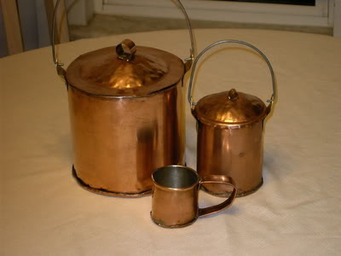

jendobyns
- Pyrate Captain
- Member

- 562 posts
- Gender:Female
- Location:Baltimore
- Interests:too numerous to mention, really. Period foodways, baroque dance, material culture, etc., etc.
Posted December 21, 2010 · Report post
Can you do re-tinning on things like the copper pot? Mine has a worn spot and looks like it might be down to the copper.
On 12/21/2010 at 9:14 AM, wes1761 said:
I have a box full of mis-matched pewter, there are plates, goblets and I think a mug or two....I'll try to get pics up, as they are Williamsburg......
Mr. Hand, I can make you a nice copper mug.....used to make a bunch of stuff..

wes1761
- Plunderer
- Member

- 358 posts
- Gender:Male
- Location:East Missouri
- Interests:shooting, my kids, history, building obscure outdated things that nobody but a history nut would understand, 4 wheeling, hunting, Pirates, Tall ships, Colonial and F and I reenacting.....etc...
Posted December 21, 2010 · Report post
Shouldnt be a problem with re-tinning......

Iron Jon
- Plunderer
- Member

- 472 posts
- Gender:Male
- Location:Palm Bay, FL
- Interests:anything that keeps me busy for a while...
Posted December 22, 2010 · Report post
I also have a collection of assorted pewter and Wilton Armetale pieces that I use, some of it is in the picture below. I'm not sure of the time period the Wilton stuff is supposed to represent. Maybe someone here can comment on the period correctness of some of these items so others can get an idea. Most of the stuff here is from thrift stores and yard sales (including my not-so-rare solid bottom horn mug!) so getting a set together for re-enactment use isn't difficult.
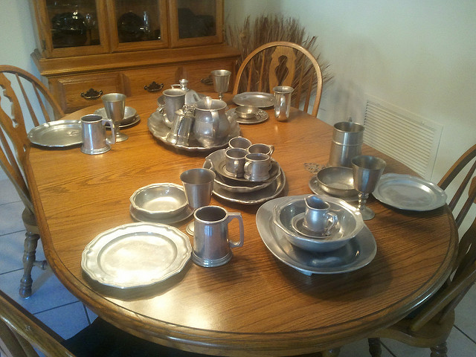

jendobyns
- Pyrate Captain
- Member

- 562 posts
- Gender:Female
- Location:Baltimore
- Interests:too numerous to mention, really. Period foodways, baroque dance, material culture, etc., etc.
Posted December 22, 2010 · Report post
On 12/21/2010 at 1:30 PM, wes1761 said:
Shouldnt be a problem with re-tinning......
Great! I'm going to check with the guy who made them first, give him a chance to stand by his product (they've barely been used and shouldn't be having this problem), but if that doesn't fly, I'll be talking to you about fixing it (or them, need to check the rest of the set). And I might know other folks whose copper needs re-tinning, so PM me if you're interested in my sharing your info with them, and info about how much it would cost (rough estimates, of course), please?
Thanks!

Korisios
- Pyrate Captain
- Member

- 565 posts
- Gender:Male
- Location:Netherlands
- Interests:Celts BC, Guatemala, Pirats
Posted December 22, 2010 · Report post
On 12/22/2010 at 0:18 PM, Iron Jon said:
I also have a collection of assorted pewter and Wilton Armetale pieces that I use, some of it is in the picture below. I'm not sure of the time period the Wilton stuff is supposed to represent. Maybe someone here can comment on the period correctness of some of these items so others can get an idea. Most of the stuff here is from thrift stores and yard sales (including my not-so-rare solid bottom horn mug!) so getting a set together for re-enactment use isn't difficult.
I like your collection Iron Jon. Or shuld I say Tin Jon...
I belief this style of tinwares is what they call Country French...

jendobyns
- Pyrate Captain
- Member

- 562 posts
- Gender:Female
- Location:Baltimore
- Interests:too numerous to mention, really. Period foodways, baroque dance, material culture, etc., etc.
Posted December 22, 2010 (edited) · Report post
My (limited) sources tell me that the shape is Queens shape (for the plates and bowls in the picture). Block molds *for ceramics* to cast elaborate shapes for plates, teapots, tankards, etc. had been established in use by the 1730's. This variation on an earlier, barley pattern style (where the plate rim was divided into sections where now you just see an indentation) appears to date later into the 18th century. Iirc, second half, 1760's or so.
I've seen this shape in metal (there's a still life or two that shows metal plates in this shape) but I seem to recall them being later half of 18C, too. Worth digging around in the arts sites. Lots to do, so I can't get into too thorough a search at the moment. Maybe when the dust settles 'round here and I can surf and dig in the books. I know of at least one pic in my collection here that shows it, by a Spanish artist.
Hope this helps somewhat!
On 12/22/2010 at 0:18 PM, Iron Jon said:
I also have a collection of assorted pewter and Wilton Armetale pieces that I use, some of it is in the picture below. I'm not sure of the time period the Wilton stuff is supposed to represent. Maybe someone here can comment on the period correctness of some of these items so others can get an idea. Most of the stuff here is from thrift stores and yard sales (including my not-so-rare solid bottom horn mug!) so getting a set together for re-enactment use isn't difficult.
Edited December 22, 2010 by jendobyns

wes1761
- Plunderer
- Member

- 358 posts
- Gender:Male
- Location:East Missouri
- Interests:shooting, my kids, history, building obscure outdated things that nobody but a history nut would understand, 4 wheeling, hunting, Pirates, Tall ships, Colonial and F and I reenacting.....etc...
Posted December 22, 2010 · Report post
Jendobyns...no sweat on sharing info, glad to help a fellow Pirate! You guys cover shipping and material and I'm happy....

jendobyns
- Pyrate Captain
- Member

- 562 posts
- Gender:Female
- Location:Baltimore
- Interests:too numerous to mention, really. Period foodways, baroque dance, material culture, etc., etc.
Posted December 22, 2010 (edited) · Report post
OK, here's one for a start: http://www.nga.gov/exhibitions/2009/melendez/index.shtm
You want painting #15, although the rest of his stuff is really cool (the cork "wine cooler" got a lot of attention with the RevWar folks)
Late for GAoP, the artist was born 1715. And I'm just starting to look for samples from earlier.
On 12/22/2010 at 0:18 PM, Iron Jon said:
I also have a collection of assorted pewter and Wilton Armetale pieces that I use, some of it is in the picture below. I'm not sure of the time period the Wilton stuff is supposed to represent. Maybe someone here can comment on the period correctness of some of these items so others can get an idea. Most of the stuff here is from thrift stores and yard sales (including my not-so-rare solid bottom horn mug!) so getting a set together for re-enactment use isn't difficult.
Edited December 22, 2010 by jendobyns

jendobyns
- Pyrate Captain
- Member

- 562 posts
- Gender:Female
- Location:Baltimore
- Interests:too numerous to mention, really. Period foodways, baroque dance, material culture, etc., etc.
Posted December 23, 2010 · Report post
art with metal and ceramic shapes for plates, etc:
Date range 1600-1700: http://www.vads.ahds.ac.uk/large.php?uid=86694&sos=2
While the date is early, I find it interesting that the blue and white ceramics are painted (and possibly shaped) like later period ceramics:
http://www.vads.ahds.ac.uk/x-large.php?uid=89508&sos=2
I think these would most likely have been Chinese in origin.
After surfing around looking at other still life paintings, the majority of earlier period pewter plates (no bowls seen at all in pewter) seem to be basic, un-ornamented round shapes. I do know an archaeologist who would be familiar with artifacts from the period and will check in with her over the holidays to see what she says. It'll be interesting to find out.
Very interesting to see that Wilton calls this pattern Country French. The pics I"ve found of anything close to that so far have been Spanish *G*

Quartermaster James
- LUNATIC
- 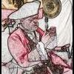
- Member

- 1,662 posts
- Gender:Male
- Location:Sailing the Islets of Langerhans
- Interests:Interests cannot be left blank, so the machine says.
Posted December 23, 2010 · Report post
I think much of what Iron Jon has is actually Wilton's Queen Anne pattern.
Country French is a different, although somewhat similar pattern.
The two are often confused, especially on eBay.
Wilton Queen Anne Pattern
Wilton Country French Pattern

Gunpowder Gertie
- Pyrate Captain
- Member

- 519 posts
- Gender:Female
- Location:Vancouver
Posted December 23, 2010 (edited) · Report post
Iron Jon! That table looked a lot like mine this Xmas!
I regularly check a site online that sells 18th century pewterware, and have bought some in fact. The period pewter seems more plain, mostly with a plain border, no decoration or scallops. However, I like the fact that the Wilton isn't goin to cause me to be antimony or lead poisoned in some way!
(However I do use the period pewter once a year..I figure it won't kill me to use it that much! )
I'm thinking that the blue and white pottery that one sees in period paintings is not only Chinese but could also be Dutch Delftware.
When I put together my sort of PC pirate table..I'll be looking at the Blue Willow pattern dinnerware as well, since it's fairly easy to come by, and the blue and white pattern looks similar to the period.
But that's just me.
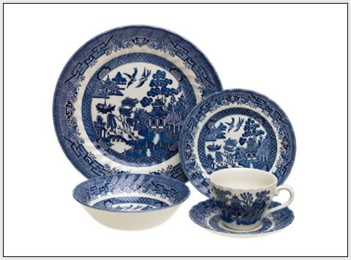
Edited December 23, 2010 by Gunpowder Gertie

Korisios
- Pyrate Captain
- Member

- 565 posts
- Gender:Male
- Location:Netherlands
- Interests:Celts BC, Guatemala, Pirats
Posted December 23, 2010 · Report post
On 12/22/2010 at 5:29 PM, jendobyns said:
OK, here's one for a start: http://www.nga.gov/e...ndez/index.shtm
You want painting #15, although the rest of his stuff is really cool (the cork "wine cooler" got a lot of attention with the RevWar folks)
Late for GAoP, the artist was born 1715. And I'm just starting to look for samples from earlier.
thanks jendobyns. these pictures are cool and it's extra nice that the paintings are Spanish!!
So... now I want to have a CHOCOLATE POT also...

Brass
- Deck Swabber
- Member

- 27 posts
- Gender:Male
- Location:metro Detroit
- Interests:living history of all types
Posted December 23, 2010 · Report post
Indeed Ms Dobyns, great reference material. Good show and thanks for sharing!
Brass

jendobyns
- Pyrate Captain
- Member

- 562 posts
- Gender:Female
- Location:Baltimore
- Interests:too numerous to mention, really. Period foodways, baroque dance, material culture, etc., etc.
Posted December 23, 2010 · Report post
I just love Julia's stuff. Have a few pieces of it 'round here, they are all beautiful. And she is such a nice person!
On 9/28/2006 at 7:41 AM, blackjohn said:
Your one stop shop for all your clayware needs...
http://www.juliasmit...istoricpottery/
And who said the 17thC/18thC was drab... good lord... what wonderful colors... if you ever find yourself on Cape Cod, in Sandwich, make sure you visit the oldest house there. It's from the mid-to-late 1600s, and the color scheme is out of this world.

jendobyns
- Pyrate Captain
- Member

- 562 posts
- Gender:Female
- Location:Baltimore
- Interests:too numerous to mention, really. Period foodways, baroque dance, material culture, etc., etc.
Posted December 23, 2010 · Report post
On 12/23/2010 at 5:11 AM, Korisios said:
On 12/22/2010 at 5:29 PM, jendobyns said:
OK, here's one for a start: http://www.nga.gov/e...ndez/index.shtm
You want painting #15, although the rest of his stuff is really cool (the cork "wine cooler" got a lot of attention with the RevWar folks)
Late for GAoP, the artist was born 1715. And I'm just starting to look for samples from earlier.
thanks jendobyns. these pictures are cool and it's extra nice that the paintings are Spanish!!
So... now I want to have a CHOCOLATE POT also...
Ah, yes, please let me know when you find a source for those*G*
And when I get my chocolate cakes to look like the ones in the paintings, I will be a happy woman indeed. Just need more practice with the right tools.

Iron Jon
- Plunderer
- Member

- 472 posts
- Gender:Male
- Location:Palm Bay, FL
- Interests:anything that keeps me busy for a while...
Posted December 23, 2010 · Report post
Thanks for the pictures and info Jenn.
On 12/23/2010 at 2:58 AM, Quartermaster James said:
I think much of what Iron Jon has is actually Wilton's Queen Anne pattern.
Country French is a different, although somewhat similar pattern.
The two are often confused, especially on eBay.
QM James is correct that most are Queen Anne (the sets that used to be his) but there are several other designs in the set too. A lot of the actual pewter I have is plain edged and should be period. There are several other edge designs on the Wilton, I could get more pictures if anyone wants to discuss further.

callenish gunner
- Scourge o' the 7 Seas
- Member

- 2,138 posts
- Gender:Male
- Location:Pennsylvania mountains north of Clarion
- Interests:The Callenish gunner has just hoved into view looking for safe anchorage in these waters... purveyor of bladed and flintlock weaponry also leather accessories ..........painter of portraits and period scenes by avocation I'm getting my armoury business underway and will be doing as many festivals as I can ...right now along the east coast or great lakes
Posted December 23, 2010 · Report post
Aye Iron john, the scalloped edged pewter was very upperclass within period...there were many variations both in period and as repros since. Many companies have been doing the variations since the mid '70 for the Bicentennial and for the resugence of colonial homes and the look of the historic. I also have quite a bit of the Wilton Queen Anne and also the Country French. I also have quite a bit of period pewter as well but with the lead content we us it only for display. With moct foods you don'y have a lot to fear from the old pewter unless it has acidic contentthat will leach the lead out but why risk it. The modern repro tableware is safer and more versitile as it can go from freezer to oven to table. We have service for 18 in most pieces.

Capt. Sterling
- Sticky Fingers Sterling Needs a New Hat
- Member

- 10,302 posts
- Gender:Pyrate Hunter
- Location:here
- Interests:Killing pirates, haven't met one yet worth keeping alive....
Posted December 24, 2010 · Report post
ah, fwiw, haven't read it myself... sorry will let others set the table...but perhaps this might be of help...
http://www.archive.org/stream/pewterplatehisto00massuoft/pewterplatehisto00massuoft_djvu.txt
"Domestic pewter of 17th century England - A Historical Re-enactors guide to the Industry and it’s products" (ISBN 1 85804 199 6 ..... Published;Stuart Press)
and a few samples from the Queen Anne's Revenge excavation
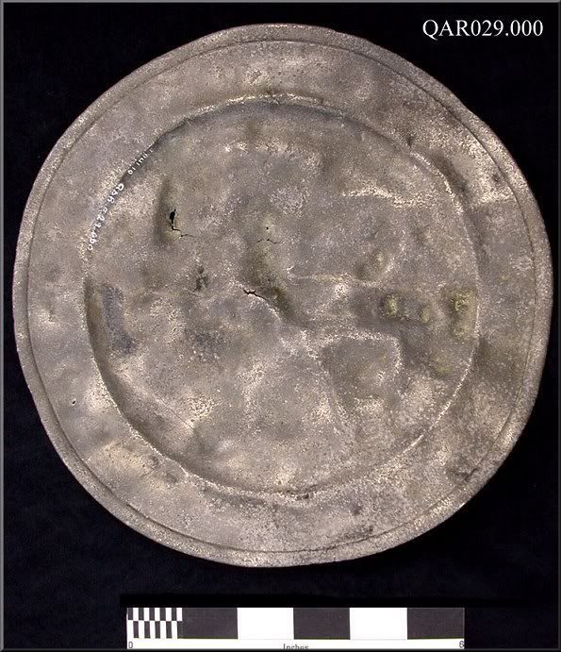
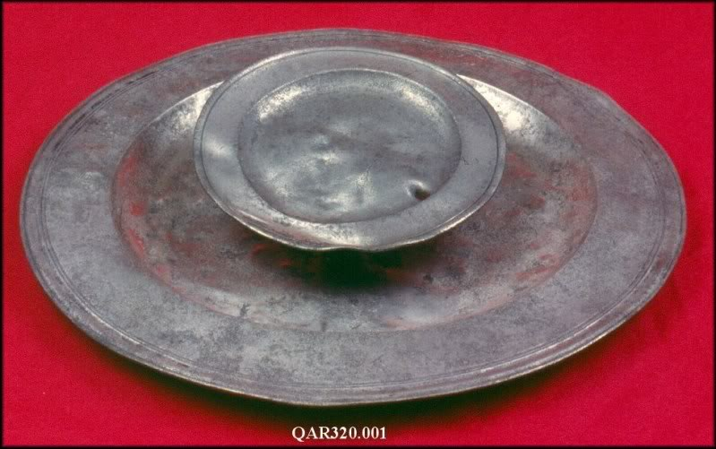
and Whydah
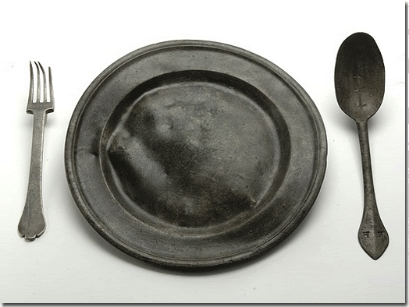

Capt. Sterling
- Sticky Fingers Sterling Needs a New Hat
- Member

- 10,302 posts
- Gender:Pyrate Hunter
- Location:here
- Interests:Killing pirates, haven't met one yet worth keeping alive....
Posted December 24, 2010 · Report post
http://www.pewtertankardsflagons.com/index.php?p=1_7_British

jendobyns
- Pyrate Captain
- Member

- 562 posts
- Gender:Female
- Location:Baltimore
- Interests:too numerous to mention, really. Period foodways, baroque dance, material culture, etc., etc.
Posted December 24, 2010 · Report post
On 12/24/2010 at 11:17 AM, Capt. Sterling said:
http://www.pewtertan...p?p=1_7_British
Thanks for that, and the previous one as well. My holiday reading list is becoming quite full *G*
The pics from the QAR look just like the things I was finding in the earlier artwork. I love it when art and archaeology converge

Jack Roberts
- Dread Pyrate
- Member

- 1,063 posts
- Gender:Male
- Location:Orlando, FL
Posted December 24, 2010 · Report post
Got some pics from V and A museum that I took. Enjoy!
TANKARD
with Britannia standard hallmark
Hallmarked for 1704- 1705
The Britannia standard hallmark indicated a higher proportion of pure silver metal than the quality of silver
generally then in ise. Britannia standard was introduced in 1697 to prevent silversmiths melting down coins to make new objects. That
practice was severely reducing the number of coins in circulation.
Silver, engraved
Made in London by Philip Rollos (born about 1660, died after 1715) Engraved with the royal coat of arms for Queen Anne, who presented
it to Goerge Proctor (died 1751) as a christening gift.
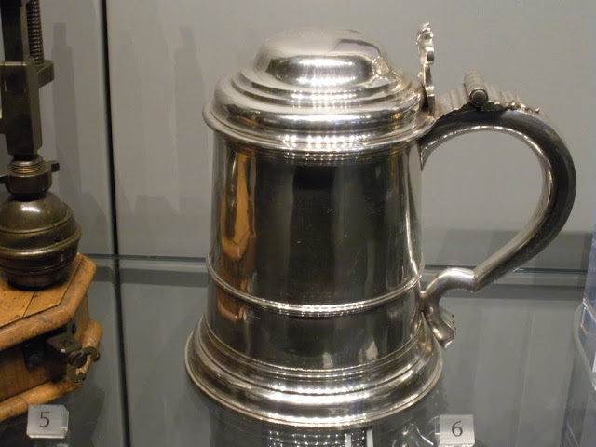

Jack Roberts
- Dread Pyrate
- Member

- 1,063 posts
- Gender:Male
- Location:Orlando, FL
Posted December 24, 2010 (edited) · Report post
And one more. Slightly after period but close...
Dish
Cast Pewter
London, England; 1725-60
Maker's tough of John Watts (active from 1725)
Stamped with a crowned rose, a crowned "X" and "WITHOUT ALDGATE":engraved squirrel crest.
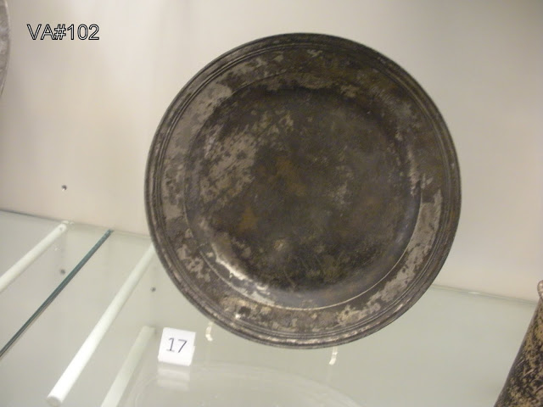
PS Ignore the text in the photo. That's my personal numbering for cataloging the placards and pics.
Edited December 24, 2010 by Jack Roberts

Jack Roberts
- Dread Pyrate
- Member

- 1,063 posts
- Gender:Male
- Location:Orlando, FL
Posted December 24, 2010 · Report post
Oooh I forgot about this one.
The left is a wine serving cup and the right is a kind of decanter.
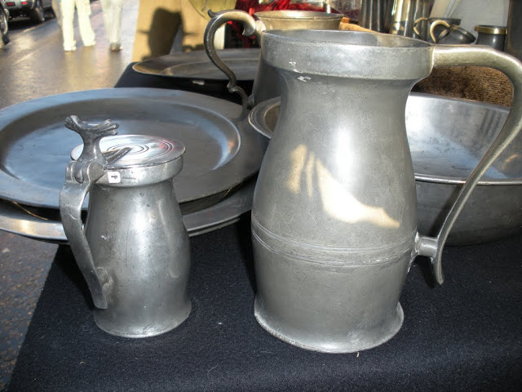

Bos'n Cross
- Pyrate Captain
- Member

- 536 posts
- Gender:Male
- Location:Portsmouth
- Interests:many things.......
Posted December 25, 2010 · Report post
i really need to visit that museum!

Jack Roberts
- Dread Pyrate
- Member

- 1,063 posts
- Gender:Male
- Location:Orlando, FL
Posted December 25, 2010 · Report post
We should plan a crewe trip.... now wouldn't that be a blast!!!

PoD
- Pyrate Captain
- Member

- 696 posts
- Gender:Male
- Location:Warrington UK
- Interests:Pirates, graphic novels, computer art, Listening to music, Going to gigs, Beer and Wine drinking, historical research, Period weaponry and Leatherwork
Posted December 25, 2010 · Report post
On 12/24/2010 at 10:58 AM, Capt. Sterling said:
I dont suppose anyone knows anywhere that does a replica of a fork like this one do they?

MadL
- Dread Pyrate
- Member

- 1,283 posts
- Gender:Male
- Location:Where ever I need ta be
- Interests:I like pirates, ye got a problem with that?
Blame me mu'm, she the one who decked me room out like a captain's cabin an' that be what I grew'd up in. Also me pa fer he built boats when I was but a wee lad. Later they ran off an' joined the carnivals, so I learn ta be a scalawag from the best.
I like weapons, some that go BOOM, and always sharp shiny ones.
I work with computers, currently contracted to hire by Xerox, their engineers [I]Need[/I] all the help they can get, this is fer sure! But I also have taught the Microsoft Certification course for a private contact school, an' spent 4 years working third level support at Earthlink before that scalawag Sky jumped ship an' let it go down.
They call me Mad L cuz, well, cuz many think I be mad, mad as a hatter they say but that only because they never jumped from a perfectly good airplane....over a thousand times. They also call me Mad L cuz I don't much like dogs n' cats, but I like things with scales and teeth, even the venomous ones for they be quit tasty when roasted over an open flame....even bet'r wit rum! They also call me Mad L, well, cuz very few know how to say me sir name properly, so in the military they give up and just call me "Mad L"
Oh, an' I dabble in the arts, computer 3D arts that be. Thar they all think I be mad, I do me best to make sure they all know I be mad. I have fun run'n amok as a pirate monkey character and makin' the moderators thar go bald. Several times the moderators try ta toss me o'r board, but the crew say will have none o' that now ;\
So, I like pirates, ye got a problem with that?
Posted December 25, 2010 (edited) · Report post
What about leather? I know leather predates the GAoP and leather hardening techniques have been around since midevil day.
The Royal Armories museum offers this one:
Royal Armories Meseum Shop
it states:
Quote
These handmade leather tankards are modelled on the shape of tankards recovered from the Mary Rose, Henry VIII's flagship.
however I have not seen nor read anywhere of their findings after 1500/1600 ?
*************************
To reply to m'self, I just came across this "The History of Leather Drinking Vessels" on a UK page; they claim:
Quote
Later fashion, particularly in Tudor times, added a wider base, presumably to promote better stability as found with those discovered with the wreck of the Mary Rose.
However, use of the jack continued until Nelsons time when they were known as Boots, hence the naval phrase "Fill up your Boots" meaning "have a drink".
and they go on to say they were still used in the 20th century and popular among the mining and steel industries; but I digress as we are all 'dead' by this time...
The History of Leather Drinking Vessels
Edited December 25, 2010 by MadL

Korisios
- Pyrate Captain
- Member

- 565 posts
- Gender:Male
- Location:Netherlands
- Interests:Celts BC, Guatemala, Pirats
Posted December 26, 2010 · Report post
Cool info guys and girls thanks!
And uh keep it comming...

Korisios
- Pyrate Captain
- Member

- 565 posts
- Gender:Male
- Location:Netherlands
- Interests:Celts BC, Guatemala, Pirats
Posted December 26, 2010 (edited) · Report post
On 12/23/2010 at 1:21 PM, jendobyns said:
On 12/23/2010 at 5:11 AM, Korisios said:
On 12/22/2010 at 5:29 PM, jendobyns said:
OK, here's one for a start: http://www.nga.gov/e...ndez/index.shtm
You want painting #15, although the rest of his stuff is really cool (the cork "wine cooler" got a lot of attention with the RevWar folks)
Late for GAoP, the artist was born 1715. And I'm just starting to look for samples from earlier.
thanks jendobyns. these pictures are cool and it's extra nice that the paintings are Spanish!!
So... now I want to have a CHOCOLATE POT also...
Ah, yes, please let me know when you find a source for those*G*
And when I get my chocolate cakes to look like the ones in the paintings, I will be a happy woman indeed. Just need more practice with the right tools.
The source? That's easy it's already on this thread... My link ... scroll 2/3 down fore the 1703 version like on the paintings...
Edited December 26, 2010 by Korisios

jendobyns
- Pyrate Captain
- Member

- 562 posts
- Gender:Female
- Location:Baltimore
- Interests:too numerous to mention, really. Period foodways, baroque dance, material culture, etc., etc.
Posted December 26, 2010 · Report post
On 12/26/2010 at 6:18 AM, Korisios said:
On 12/23/2010 at 1:21 PM, jendobyns said:
On 12/23/2010 at 5:11 AM, Korisios said:
On 12/22/2010 at 5:29 PM, jendobyns said:
OK, here's one for a start: http://www.nga.gov/e...ndez/index.shtm
You want painting #15, although the rest of his stuff is really cool (the cork "wine cooler" got a lot of attention with the RevWar folks)
Late for GAoP, the artist was born 1715. And I'm just starting to look for samples from earlier.
thanks jendobyns. these pictures are cool and it's extra nice that the paintings are Spanish!!
So... now I want to have a CHOCOLATE POT also...
Ah, yes, please let me know when you find a source for those*G*
And when I get my chocolate cakes to look like the ones in the paintings, I will be a happy woman indeed. Just need more practice with the right tools.
The source? That's easy it's already on this thread... My link ... scroll 2/3 down fore the 1703 version like on the paintings...
Oops, sorry about that, I was thinking ceramic! The copper are definitely available, and he does excellent work. I may just spring for one of Peter's, as the copper is so much more durable. My brain's just been stuck on ceramics lately, bein' a Redcoat officer's wife and all.

jendobyns
- Pyrate Captain
- Member

- 562 posts
- Gender:Female
- Location:Baltimore
- Interests:too numerous to mention, really. Period foodways, baroque dance, material culture, etc., etc.
Posted December 26, 2010 · Report post
On 12/25/2010 at 8:48 PM, MadL said:
What about leather? I know leather predates the GAoP and leather hardening techniques have been around since midevil day.
The Royal Armories museum offers this one:
Royal Armories Meseum Shop
it states:
Quote
These handmade leather tankards are modelled on the shape of tankards recovered from the Mary Rose, Henry VIII's flagship.
however I have not seen nor read anywhere of their findings after 1500/1600 ?
*************************
To reply to m'self, I just came across this "The History of Leather Drinking Vessels" on a UK page; they claim:
Quote
Later fashion, particularly in Tudor times, added a wider base, presumably to promote better stability as found with those discovered with the wreck of the Mary Rose.
However, use of the jack continued until Nelsons time when they were known as Boots, hence the naval phrase "Fill up your Boots" meaning "have a drink".
and they go on to say they were still used in the 20th century and popular among the mining and steel industries; but I digress as we are all 'dead' by this time...
The History of Leather Drinking Vessels
Oh, those Royal Armories leather jacks are lovely!

MarkG
- Pyrate Captain
- Member

- 587 posts
- Location:Ohio
Posted December 28, 2010 · Report post
On 12/24/2010 at 3:53 PM, Jack Roberts said:
Oooh I forgot about this one.
The left is a wine serving cup and the right is a kind of decanter.
The one on the right looks like a measure to me. Probably a full pint.
Mark

LadyBarbossa
- Wealth Redistributor & Mischief Making
- Moderator

- 4,641 posts
- Gender:Female
- Location:The Land Between Two Rivers, aka Iowa
- Interests:18th c Piracy to American Revolution, Victorian Thespians, Equitation, tigers, Friesians, cooking, playing my viola & music in general. Researcher of Major General Baron Johann de Kalb. LOVES the Phantom of the Opera (who's also Brethren)! Transformers, Stargate, Star Trek, Star Wars, NCIS, Bones, The X Files
Posted December 29, 2010 · Report post
On 12/22/2010 at 0:18 PM, Iron Jon said:
I also have a collection of assorted pewter and Wilton Armetale pieces that I use, some of it is in the picture below. I'm not sure of the time period the Wilton stuff is supposed to represent. Maybe someone here can comment on the period correctness of some of these items so others can get an idea. Most of the stuff here is from thrift stores and yard sales (including my not-so-rare solid bottom horn mug!) so getting a set together for re-enactment use isn't difficult.
Tis a nice table setting indeed, Iron Jon. I think Jen had hit as close to the nail as one can get. Pewter like this wasn't nailed down to a decade.
On 12/23/2010 at 3:14 AM, Gunpowder Gertie said:
Iron Jon! That table looked a lot like mine this Xmas!
I regularly check a site online that sells 18th century pewterware, and have bought some in fact. The period pewter seems more plain, mostly with a plain border, no decoration or scallops. However, I like the fact that the Wilton isn't goin to cause me to be antimony or lead poisoned in some way!
(However I do use the period pewter once a year..I figure it won't kill me to use it that much! )
I'm thinking that the blue and white pottery that one sees in period paintings is not only Chinese but could also be Dutch Delftware.
When I put together my sort of PC pirate table..I'll be looking at the Blue Willow pattern dinnerware as well, since it's fairly easy to come by, and the blue and white pattern looks similar to the period.
But that's just me.
Aye, Gertie! I've found a couple pieces that can be close enough if not spot on! I recently purchased a plate from a thrift store that was white with the period appropriate blue florial design! It's perfect to the period style. Sometimes, you can find them. If I get the opportunity, I'll take a picture of the plate and post it here.
I have found that the pflatsgraf Yorktown and Villiage plates are pretty close, too. The yorktown more an off-white with a dirty blue painted floral while the village (which is what I have and have been using at events, even Rev War) are yellow with the same floral design but in brown.
PoD, I have not found anyone yet. But, perhaps you can check with Gibson Pewter. They specialize in Colonial Era pewter. Perhaps they can do a special order of that same fork for ye. It is a really nice fork. I wouldn't mind having a replica or few of that fork, either.
Generally I've been googling and finding a LOT of great stuff on period appropriate items for the table.
~Lady B

callenish gunner
- Scourge o' the 7 Seas
- Member

- 2,138 posts
- Gender:Male
- Location:Pennsylvania mountains north of Clarion
- Interests:The Callenish gunner has just hoved into view looking for safe anchorage in these waters... purveyor of bladed and flintlock weaponry also leather accessories ..........painter of portraits and period scenes by avocation I'm getting my armoury business underway and will be doing as many festivals as I can ...right now along the east coast or great lakes
Posted December 29, 2010 · Report post
[/img]
This is just a portion of the ware for the table we set. I've always liked to welcome guests with to a fine table and have them well fed.
A good supper and fine drynke; friends deserve nothing less

callenish gunner
- Scourge o' the 7 Seas
- Member

- 2,138 posts
- Gender:Male
- Location:Pennsylvania mountains north of Clarion
- Interests:The Callenish gunner has just hoved into view looking for safe anchorage in these waters... purveyor of bladed and flintlock weaponry also leather accessories ..........painter of portraits and period scenes by avocation I'm getting my armoury business underway and will be doing as many festivals as I can ...right now along the east coast or great lakes
Posted December 29, 2010 (edited) · Report post
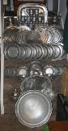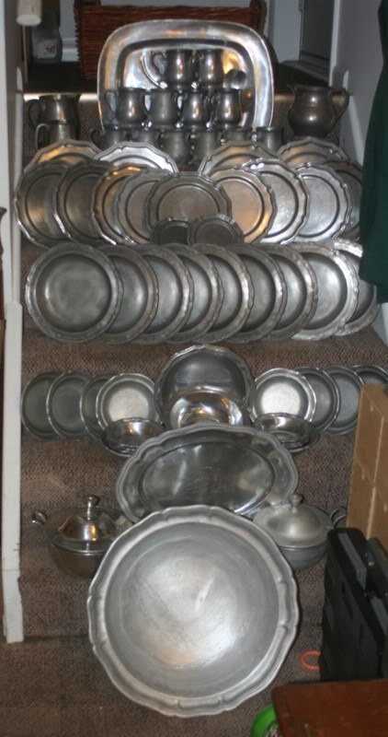
This is just a portion of the ware for the table we set. I've always liked to welcome guests with to a fine table and have them well fed.
A good supper and fine drynke; friends deserve nothing less
Edited December 29, 2010 by callenish gunner

PoD
- Pyrate Captain
- Member

- 696 posts
- Gender:Male
- Location:Warrington UK
- Interests:Pirates, graphic novels, computer art, Listening to music, Going to gigs, Beer and Wine drinking, historical research, Period weaponry and Leatherwork
Posted December 29, 2010 · Report post
They have some really great reproductions at this place including some forks but not one that looks like the one pictured above:
http://www.amerheritage.com/salespages/pewter/aslpewter-1.htm

LadyBarbossa
- Wealth Redistributor & Mischief Making
- Moderator

- 4,641 posts
- Gender:Female
- Location:The Land Between Two Rivers, aka Iowa
- Interests:18th c Piracy to American Revolution, Victorian Thespians, Equitation, tigers, Friesians, cooking, playing my viola & music in general. Researcher of Major General Baron Johann de Kalb. LOVES the Phantom of the Opera (who's also Brethren)! Transformers, Stargate, Star Trek, Star Wars, NCIS, Bones, The X Files
Posted December 29, 2010 · Report post
Nice find, PoD! I like this place, too! Kudos, mate. :)
Wes! Look... SPOONS! Even forks. :)
~Lady B

wes1761
- Plunderer
- Member

- 358 posts
- Gender:Male
- Location:East Missouri
- Interests:shooting, my kids, history, building obscure outdated things that nobody but a history nut would understand, 4 wheeling, hunting, Pirates, Tall ships, Colonial and F and I reenacting.....etc...
Posted December 29, 2010 · Report post
HA!! I see that! I am still trying to find time to cast some repops of the spoon I have. I'll try to get a pic posted....
Found a bunch of old pewter, might melt it down for the casting...or I'll just order ingots....

Quartermaster James
- LUNATIC
- Member

- 1,662 posts
- Gender:Male
- Location:Sailing the Islets of Langerhans
- Interests:Interests cannot be left blank, so the machine says.
Posted December 30, 2010 · Report post
On 12/25/2010 at 6:29 PM, PoD said:
On 12/24/2010 at 10:58 AM, Capt. Sterling said:
I dont suppose anyone knows anywhere that does a replica of a fork like this one do they?
Not exactly the same, but made from period molds: http://www.thomasdalecompany.com/as-flt6.html

PoD
- Pyrate Captain
- Member

- 696 posts
- Gender:Male
- Location:Warrington UK
- Interests:Pirates, graphic novels, computer art, Listening to music, Going to gigs, Beer and Wine drinking, historical research, Period weaponry and Leatherwork
Posted December 30, 2010 · Report post
On 12/30/2010 at 1:42 AM, Quartermaster James said:
On 12/25/2010 at 6:29 PM, PoD said:
On 12/24/2010 at 10:58 AM, Capt. Sterling said:
I dont suppose anyone knows anywhere that does a replica of a fork like this one do they?
Not exactly the same, but made from period molds: http://www.thomasdal...om/as-flt6.html
Thanks i will be ordering that as soon as they open for business

Quartermaster James
- LUNATIC
- Member

- 1,662 posts
- Gender:Male
- Location:Sailing the Islets of Langerhans
- Interests:Interests cannot be left blank, so the machine says.
Posted December 30, 2010 · Report post
On 12/30/2010 at 5:53 PM, PoD said:
Thanks i will be ordering that as soon as they open for business
Happy to help. I think it will go nicely with those spoons of yours.
When it arrives, can you PM me and let me know how much it weighs?

PoD
- Pyrate Captain
- Member

- 696 posts
- Gender:Male
- Location:Warrington UK
- Interests:Pirates, graphic novels, computer art, Listening to music, Going to gigs, Beer and Wine drinking, historical research, Period weaponry and Leatherwork
Posted December 31, 2010 · Report post
On 12/30/2010 at 6:18 PM, Quartermaster James said:
On 12/30/2010 at 5:53 PM, PoD said:
Thanks i will be ordering that as soon as they open for business
Happy to help. I think it will go nicely with those spoons of yours.
When it arrives, can you PM me and let me know how much it weighs?
yeah no problem. probably take a few weeks to get here

Brit.Privateer
- Old Twillian
- Member

- 246 posts
- Gender:Male
- Location:North Carolina
- Interests:Atlantic World Maritime History during the Colonial Era. I specialize in early provincial era (1680-1740) and do quite a bit with pirate history.
Posted July 2, 2011 · Report post
It's me again, in quest of information again.
In my searches of this forum, online, and through the various databases I have access to online, it seems there is somewhat of lack in information on period cups and tankards. The only exception to this role appears to be a few pewter tankards discovered through archaeology. But I am more interested in the non-pewter kind. What kind of cup or tankard would a common person or sailor of the late seventeenth or early eighteenth century use? I've seen one or two very un-detailed pictures of cups, but these pictures often don't give details on their size or construction.
Have any of you done any kind of research relating to this? Some pointers on the subject to get me in the right direction would be very helpful right now.

jollyjacktar
- Deck Hand
- Member

- 67 posts
- Gender:Male
- Location:Charleston, SC
- Interests:Sailing, knots, maritime history and education, cannons, black powder, reading, sewing, carving, research... god far too many to list.
Posted July 3, 2011 · Report post
I've got to be quick, but I know that a number of staved drinking vessels were found on sailing ships from the 16th through 19th centuries.
Yours & co

Lawrence Brown
- Bilge Rat
- Member

- 2 posts
Posted July 3, 2011 · Report post
Here is a leather jug dated to the 17th or 18th century (not very specific, unfortunately).
http://nms.scran.ac.uk/database/record.php?usi=000-100-002-786-C
I've seen similar ones dated just to the 17th century, though, like this one: http://www.bunrattycollection.com/search.php?i=143

Littleneckhalfshell
- Plunderer
- Member

- 390 posts
- Gender:Male
- Location:Hudson Valley, NY
- Interests:Blacksmithing, hunting, fishing, stuff.......
Posted July 3, 2011 · Report post
I have some pictures of staved drinking tankards, and a carved one, I will see if I can upload them. I believe one of them is from the Mary Rose, but all were period to my rememberance.

Littleneckhalfshell
- Plunderer
- Member

- 390 posts
- Gender:Male
- Location:Hudson Valley, NY
- Interests:Blacksmithing, hunting, fishing, stuff.......
Posted July 3, 2011 (edited) · Report post
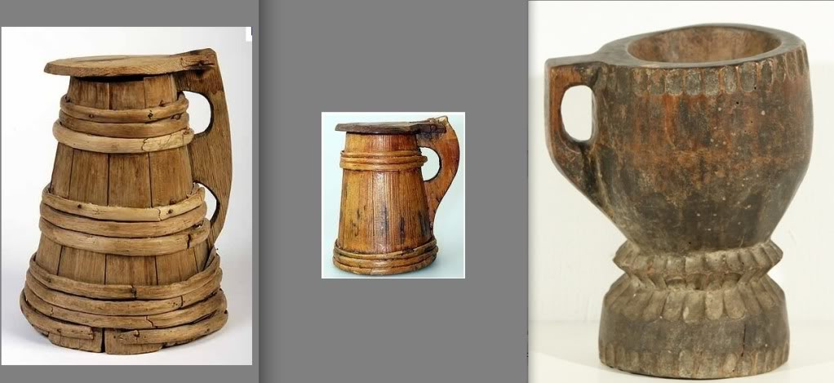
Hope this works, been a while since I tried posting a picture.
Edited July 3, 2011 by Littleneckhalfshell

Brit.Privateer
- Old Twillian
- Member

- 246 posts
- Gender:Male
- Location:North Carolina
- Interests:Atlantic World Maritime History during the Colonial Era. I specialize in early provincial era (1680-1740) and do quite a bit with pirate history.
Posted July 3, 2011 · Report post
On 7/3/2011 at 1:59 PM, Littleneckhalfshell said:
Hope this works, been a while since I tried posting a picture.
Well, that's a start. I've seen the leather sort before, but as I said in the first post, I am more interested in the wooden kind. I would really like to see some documentation on seventeenth and eighteenth century cups and tankards though. I am surprised that I couldn't find any articles written in archaeology about the subject.
The one from the Mary Rose looks interesting.

Brit.Privateer
- Old Twillian
- Member

- 246 posts
- Gender:Male
- Location:North Carolina
- Interests:Atlantic World Maritime History during the Colonial Era. I specialize in early provincial era (1680-1740) and do quite a bit with pirate history.
Posted July 3, 2011 · Report post
Well, I did find one thing that was kind of interesting. Horn Cups:
http://www.cottoneauctions.com/oldsite/old/images/TomWnuck/cups.jpg
they are from an Estate sale that have a lot of eighteenth century items. This lot is described as 1 horn cup with silver mount, and six horn cups.
The search continues.

Brit.Privateer
- Old Twillian
- Member

- 246 posts
- Gender:Male
- Location:North Carolina
- Interests:Atlantic World Maritime History during the Colonial Era. I specialize in early provincial era (1680-1740) and do quite a bit with pirate history.
Posted July 4, 2011 · Report post
Digging deeper into my private collections, I did find a couple of pictures that might help. For one, the Mary Rose style tankard appears to have gone well into the eighteenth century, if we are to believe the accuracy of a picture "The Sailors Parting" by C. Mosely in 1743. I would post it, but having troubles with that right now. The picture is questionable because the picture shows a sailor and a lady on a unbelievably large gun duck (there is at least two feet of head room for someone standing) and a gun port that is less of a port and more of a very large window.
The other picture can be seen on Foxe's website here: http://pic100.picturetrail.com/VOL762/3253847/6655055/85754627.jpg Not sure if the sailors owned the cups though. Hard to tell based on these pics.
Also, been looking through the Port Royal findings that Texas A&M did in the 90s, and it seems like there were many more pewter mugs than I thought, and many stoneware ones as well. These studies also helped me clarify some terminology. A cup seems to be more defined as something holding around a pint or two of liquid. Mug or tankard is a tall drinking vessel, and is what I am more interested in documenting. And then there are flagons, which is more for pouring liquid into smaller vessels.
Any other contributions are still appreciated.

Lawrence Brown
- Bilge Rat
- Member

- 2 posts
Posted July 4, 2011 · Report post
On page 229 of "Early American Antique Country Furnishings" by George Neumann, there are pictures of two wooden tankards with bound staves and hinged lids, similar to the Mary Rose tankard, dated 1750-1780 and 1740-1790. The only differences that I could really see from the pictures are that the lids are slightly more domed and the handles are more square.
If you search for it on Amazon (ISBN 0517661837), you can search inside the book if you have an Amazon account. I just searched "tankard".

Ivan Henry aka Moose
- Plunderer
- Member

- 486 posts
- Gender:Male
- Location:tampa, fl
- Interests:Bicycles
Travel
Wine
Beer
Good Food
Pizza!
Pirate Stuff
Design
Posted July 5, 2011 · Report post
I have had a good deal of 16th - 18th Century drinking vessel research. THis topic motivated me to do something with it. Here you go! Have fun!
Drinking Vessel Research

Brit.Privateer
- Old Twillian
- Member

- 246 posts
- Gender:Male
- Location:North Carolina
- Interests:Atlantic World Maritime History during the Colonial Era. I specialize in early provincial era (1680-1740) and do quite a bit with pirate history.
Posted July 5, 2011 · Report post
On 7/5/2011 at 3:12 PM, Ivan Henry aka Moose said:
I have had a good deal of 16th - 18th Century drinking vessel research. THis topic motivated me to do something with it. Here you go! Have fun!
Drinking Vessel Research
That is A LOT of pictures for period drinking vessels. And you give a little bit of everything, wood, glass, pewter, and so on. Plus, those pictures will be useful for more than just mugs. Thank you for that Ivan.
Meanwhile, I somehow found a thread I missed before on sellers of various cooking and eating implements:
Didn't net me much new stuff for sources though for what I was really looking for, but turned up interesting stuff none the less. For instance, these sellers of mostly copper items on the bottom have some interesting iron flagon and a iron tankard from the mid 18th century (see the bottom of the page, "from our collection"): http://www.goosebay-workshops.com/CUPS-CANTEENS
And, for those interested in pewter tankards, flagons, and such; there is this: http://www.pewtertankardsflagons.com/index.php?p=1_7_British
well, onward with my search.

Grymm
- First Mate
- Member

- 281 posts
- Gender:Male
- Location:Chilterns UK
- Interests:Stuff
Posted July 6, 2011 · Report post
In the UK either go to Reiver Trading or directly to A.E. Williams in Birmingham. Williams mould store is a treasure trove with moulds going back to 1620 maybe even earlier. Ignore the tourist tat on the website and talk to them direct.

IvanHenry
- Deck Swabber
- Member

- 44 posts
Posted July 11, 2011 · Report post
I have some drinking vessel research posted in a gallery here:
http://www.ivanhenry.com/extras/16th_17th_18th_century_drinking_vessel.html

Mission
- Goat Specialist
- Admin

- 5,081 posts
- Gender:Male
- Location:Monroe, MI
- Interests:Scholarly piracy, designing and creating haunted house rooms and props, movies, abstract thinking, abstruse thinking, obstructive thinking, ideating, random thinking, movies, cartoons, movies, movies scores, cycling, world peace and small furry dogs, movies, writing, drawing, personal skills training, gremlins and, of course, lest I forget, movies.
Posted September 22, 2011 · Report post
On 12/20/2010 at 10:32 PM, jendobyns said:
On 12/20/2010 at 1:24 PM, Commodore Greyhound said:
There were also tankards with glass bottoms so the wary drinker could keep an eye on the tavern suroundings, even when drinking, in case a foe or anything unsavery approached. My mom has a bunch of those in her basement from when we were on a local Medieval Faire's cast
Interesting. I had always heard that the reason there were glass bottoms was so the drinker could check and make sure there were no coins in the bottom. If the King's recruiting sergeant was buying drinks, a ploy to get recruits to "take the king's shilling", thus essentially signing on to military service, was to put the coin in the tankard. When they got to the bottom they'd pick it up out of the tankard ( lookit this! there's money in me grog!), thus "taking the King's shilling". I'd also heard they were a 19C invention. Worth doing some research again, I guess, to make sure what I remember isn't another reenactorism or museum myth perpetuated from docent to docent.
I have heard repeatedly that these are not correct to the Golden Age of Pyracy. In fact, if you go back to the first page, you'll find Chole makes a comment on this.

Mission
- Goat Specialist
- Admin

- 5,081 posts
- Gender:Male
- Location:Monroe, MI
- Interests:Scholarly piracy, designing and creating haunted house rooms and props, movies, abstract thinking, abstruse thinking, obstructive thinking, ideating, random thinking, movies, cartoons, movies, movies scores, cycling, world peace and small furry dogs, movies, writing, drawing, personal skills training, gremlins and, of course, lest I forget, movies.
Posted September 22, 2011 · Report post
Here is some brief info on cooking items from the book The Voyages and Travels of Captain Nathaniel Uring (1928 reprint, first published in 1726). He is describing items in a house in Virginia where he stayed for a few months in 1697 or 8. Note the lack of forks.]
]
"The Closet was made use of for their Kitchen Furniture, which consisted of an Iron Pot, a Frying-Pan, Two or Three earthen Dishes, Three or Four Pewter Plates, and as many Spoons. I lived with these poor People very agreeably..." (Uring, p. 12)

landlubbersanonymous
- Plunderer
- Member

- 354 posts
- Gender:Not Telling
- Location:California, USA
- Interests:History, arts, collecting, reenacting
Posted September 30, 2011 (edited) · Report post
The Pewter Society in the UK is currently running with a sort of pie-shaped imagery that covers 15th-19th century British plate styles. I can't vouch for its accuracy, but I wouldn't think they'd intentionally post misinformation. (Take it with a grain of salt.)
http://www.pewtersoc...es-and-saucers/
Edited September 30, 2011 by landlubbersanonymous

jendobyns
- Pyrate Captain
- Member

- 562 posts
- Gender:Female
- Location:Baltimore
- Interests:too numerous to mention, really. Period foodways, baroque dance, material culture, etc., etc.
Posted October 3, 2011 · Report post
What a wonderful reference. Thank you.

landlubbersanonymous
- Plunderer
- Member

- 354 posts
- Gender:Not Telling
- Location:California, USA
- Interests:History, arts, collecting, reenacting
Posted October 3, 2011 · Report post
On 10/3/2011 at 5:14 PM, jendobyns said:
What a wonderful reference. Thank you.
You're welcome.
(I'm saving a copy of the graphic for future reference too.)

landlubbersanonymous
- Plunderer
- Member

- 354 posts
- Gender:Not Telling
- Location:California, USA
- Interests:History, arts, collecting, reenacting
Posted October 5, 2011 (edited) · Report post
On 7/5/2011 at 10:32 PM, Brit.Privateer said:
And, for those interested in pewter tankards, flagons, and such; there is this: http://www.pewtertan...p?p=1_7_British
well, onward with my search.
I really like that site. On the links page, there's a connection to a European pewter one...
http://www.zinnmeist.../historisch.htm
Even if one can't follow all the (German) text, it's worth a visit just to view the photos, artwork and regional maps with illustrations of assorted European and British shapes and styles of drink ware that were produced through the ages. The latter came from the book Schönes Zinn by Ludwig Mory. After eyeballing these things for the better part of a year, I ventured to eBay's German site a week ago and purchased a copy. I'll be happy to share any relevant info from same once I get my mitts on it.
Edited October 5, 2011 by landlubbersanonymous

jendobyns
- Pyrate Captain
- Member

- 562 posts
- Gender:Female
- Location:Baltimore
- Interests:too numerous to mention, really. Period foodways, baroque dance, material culture, etc., etc.
Posted October 5, 2011 · Report post
oooh, very nice!

landlubbersanonymous
- Plunderer
- Member

- 354 posts
- Gender:Not Telling
- Location:California, USA
- Interests:History, arts, collecting, reenacting
Posted October 27, 2011 (edited) · Report post
The book (Schönes Zinn) arrived after a six week journey over the high seas.
I'm going to attempt to distill the mid 17th-18th century info. from that and other books/sources.
Edited October 27, 2011 by landlubbersanonymous

Grymm
- First Mate
- Member

- 281 posts
- Gender:Male
- Location:Chilterns UK
- Interests:Stuff
Posted December 16, 2011 · Report post
Slipware and stoneware is what I tend to use for late 17th-early 18thC
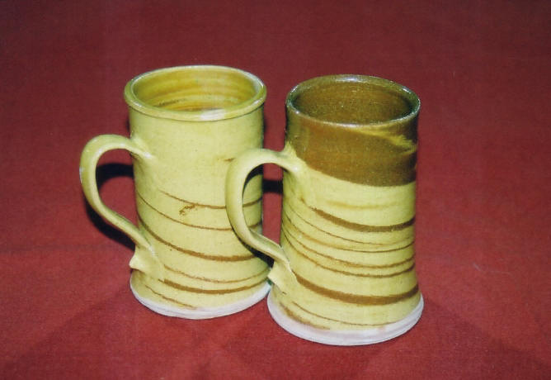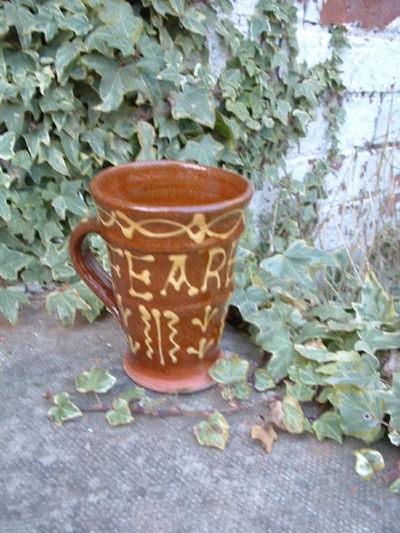
Mostly from these guys
http://www.trinitycourtpotteries.co.uk/trintiycourt_home.htm
or
http://www.hudsonclaypotter.co.uk/
Both have been known to do commissions, and the websites show a teeny amount of what they can and do produce. Best speak to them.

jendobyns
- Pyrate Captain
- Member

- 562 posts
- Gender:Female
- Location:Baltimore
- Interests:too numerous to mention, really. Period foodways, baroque dance, material culture, etc., etc.
Posted December 16, 2011 · Report post
On 12/16/2011 at 9:34 AM, Grymm said:
Slipware and stoneware is what I tend to use for late 17th-early 18thC
Mostly from these guys
http://www.trinityco...ycourt_home.htm
or
http://www.hudsonclaypotter.co.uk/
Both have been known to do commissions, and the websites show a teeny amount of what they can and do produce. Best speak to them.
Those are gorgeous pieces! Lucky you!

landlubbersanonymous
- Plunderer
- Member

- 354 posts
- Gender:Not Telling
- Location:California, USA
- Interests:History, arts, collecting, reenacting
Posted January 15, 2012 (edited) · Report post
Noteworthy biographical info re: Simon Benning, (the English pewterer who'd set up shop in Port Royal, Jamaica) from the PR Project.
http://nautarch.tamu...al/research.htm
(Msg me for the text if link becomes disabled/obsolete.)
Edited January 15, 2012 by landlubbersanonymous

Johnathan Atwood
- Deck Swabber
- Member

- 40 posts
- Gender:Male
- Location:Isle of Rhodes
- Interests:Sailin', Stabbin', Shootin'
Posted January 27, 2012 · Report post
I've seen a lot on here for pewter, tin, and copper mugs. What about leather Black Jacks lined with brewer's pitch? I have one and have heard its accurate, but to be honest I have seen very little documentation beyond the Eyewitness Books: Pirate, from DK Publishing.

landlubbersanonymous
- Plunderer
- Member

- 354 posts
- Gender:Not Telling
- Location:California, USA
- Interests:History, arts, collecting, reenacting
Posted January 28, 2012 (edited) · Report post
On 1/27/2012 at 11:07 PM, Johnathan Atwood said:
I've seen a lot on here for pewter, tin, and copper mugs. What about leather Black Jacks lined with brewer's pitch? I have one and have heard its accurate, but to be honest I have seen very little documentation beyond the Eyewitness Books: Pirate, from DK Publishing.
Not references to pirates AND Black Jacks per se but general (period) info...
A couple of the mugs appear in Early American Antique Country Furnishings by George Neumann
(Recommended general reference on period related items of all sorts.)
A link to Black Jacks and Leather Bottells: Being some account of leather drinking vessels in England by Oliver Baker (1921) It may take a couple minutes to load....
http://www.scribd.co...eather-Bottells
Some museum links here...
http://www.museumofl...bject&id=440161
http://www.museumofl...rg/black-jacks/
http://collections.v...523/black-jack/
http://collections.v...862/black-jack/
Pyracy forum threads with info related to these creatures...
http://pyracy.com/in...showtopic=16722
http://pyracy.com/in...showtopic=18181
Some interesting DIY info from another site...
http://www.modaruniv...y.org/Jacks.htm
Edited January 28, 2012 by landlubbersanonymous

Johnathan Atwood
- Deck Swabber
- Member

- 40 posts
- Gender:Male
- Location:Isle of Rhodes
- Interests:Sailin', Stabbin', Shootin'
Posted January 28, 2012 · Report post
Much Obliged! I think I'll try making a few! I'll post pics if they turn out well.

landlubbersanonymous
- Plunderer
- Member

- 354 posts
- Gender:Not Telling
- Location:California, USA
- Interests:History, arts, collecting, reenacting
Posted March 21, 2012 (edited) · Report post
Here's a nifty illustration of a period marketplace in Alsace featuring all manner of goods. This image is from Schönes Zinn and can also be found reproduced in PEWTER at the Victoria and Albert Museum. The artist is reportedly unknown. (Note predatory parrot on center canopy waiting to wreak havoc on its next unsuspecting victim.)
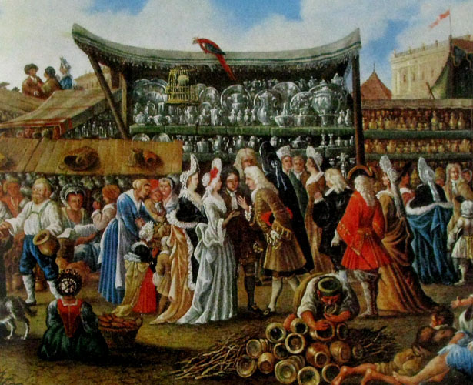
Edited March 22, 2012 by landlubbersanonymous

Swashbuckler 1700
- Dread Pyrate
- Member

- 1,115 posts
- Gender:Male
- Location:Europe
- Interests:pyrates, pryvateers, naval military and other history, different books, good movies, music (a little bit), drawing, games,...
Posted March 26, 2012 (edited) · Report post
Port Royal again
http://www.youtube.com/watch?v=850J9tYPd28
see 7.50.... Documentaries are often bad but this is good....
Edited March 26, 2012 by Swashbuckler 1700

Grymm
- First Mate
- Member

- 281 posts
- Gender:Male
- Location:Chilterns UK
- Interests:Stuff
Posted March 27, 2012 · Report post
For some f*%£ing gorgeous period correct glassware these chaps are the bee's knees, wasp's nipples, grasshoppers privates, in fact name an erogenous zone and and insect and they are it.......well I think so =o)
http://www.georgianglassmakers.co.uk/gallerybalusters.htm
Luckily they were having a sale at TORM so I got me some of their bootiful handblown/made drinking glasses without having to rent The Mem Sahib to passing sailors.
For period pewter I go to AE Williams in Birmingham direct, I was luck enough to have a mooch round their mould store and they have quite a few that date back to the 17th & 18thC so what comes out is pretty much spot on apart from the alloy itself.
Reiver Trading also sell Williams stuff
http://www.reivertrading.co.uk/index.html

jendobyns
- Pyrate Captain
- Member

- 562 posts
- Gender:Female
- Location:Baltimore
- Interests:too numerous to mention, really. Period foodways, baroque dance, material culture, etc., etc.
Posted March 27, 2012 · Report post
On 3/27/2012 at 4:09 PM, Grymm said:
For some f*%£ing gorgeous period correct glassware these chaps are the bee's knees, wasp's nipples, grasshoppers privates, in fact name an erogenous zone and and insect and they are it.......well I think so =o)
http://www.georgiang...rybalusters.htm
Luckily they were having a sale at TORM so I got me some of their bootiful handblown/made drinking glasses without having to rent The Mem Sahib to passing sailors.
For period pewter I go to AE Williams in Birmingham direct, I was luck enough to have a mooch round their mould store and they have quite a few that date back to the 17th & 18thC so what comes out is pretty much spot on apart from the alloy itself.
Reiver Trading also sell Williams stuff
http://www.reivertra...o.uk/index.html
Um, ah, yeah. Glassware worth lusting for! There is no emoticon for drooling, darn it!

Mission
- Goat Specialist
- Admin

- 5,081 posts
- Gender:Male
- Location:Monroe, MI
- Interests:Scholarly piracy, designing and creating haunted house rooms and props, movies, abstract thinking, abstruse thinking, obstructive thinking, ideating, random thinking, movies, cartoons, movies, movies scores, cycling, world peace and small furry dogs, movies, writing, drawing, personal skills training, gremlins and, of course, lest I forget, movies.
Posted February 28, 2014 · Report post
Reading along in David Marley's Daily Life of Pirates and I came across this, which I found interesting. Back on page two of this discussion the three- versus two-tined fork was mentioned and so when I read this, I found it interesting. (I don't know what Marley's source is for the comment; he's not always that good at citing his sources...)
"The customary eating practice at the time was to hold one's food down on a plate with a double-tined fork, cutting and passing portions of it into the mouth on the tip of a sharp knife. Spoons were also used for soups or stews, each individual's set of utensils designed to fold up or nestle into a portable kit carried on their person. A refinement that began to become more commonplace toward the end of the 17th century meant using the fork to life portions of food into one's mouth, so that three tines became the norm for forks, with round-tipped knives for cutting. Plates carried aboard most ships were usually squares made out of wood, and pewter mugs were used for drinking – although pirate crews that had been successful in looting rich merchants often dined incongruously off China or even silverware." (Marley, p. 43)

jendobyns
- Pyrate Captain
- Member

- 562 posts
- Gender:Female
- Location:Baltimore
- Interests:too numerous to mention, really. Period foodways, baroque dance, material culture, etc., etc.
Posted February 28, 2014 · Report post
So the next question would be, what is Marley's source for this information? And does the material culture of the time (eating utensils) back this up? Look at the art work of the period, museum collections, etc.

jendobyns
- Pyrate Captain
- Member

- 562 posts
- Gender:Female
- Location:Baltimore
- Interests:too numerous to mention, really. Period foodways, baroque dance, material culture, etc., etc.
Posted February 28, 2014 · Report post
I don't remember if links work here, but the Met Museum has a fork and spoon set from around 1680, the fork has _four_ tines. And that is just the top of the page.
http://www.metmuseum.org/Collections/search-the-collections/200240

Mission
- Goat Specialist
- Admin

- 5,081 posts
- Gender:Male
- Location:Monroe, MI
- Interests:Scholarly piracy, designing and creating haunted house rooms and props, movies, abstract thinking, abstruse thinking, obstructive thinking, ideating, random thinking, movies, cartoons, movies, movies scores, cycling, world peace and small furry dogs, movies, writing, drawing, personal skills training, gremlins and, of course, lest I forget, movies.
Posted March 1, 2014 · Report post
As I said, I don't know his source. I have already found one apparent factual error in his book, so maybe he's wrong. (He also has some rather dubious things to say about earrings IMO, but I didn't want to dredge that hoary topic up.) To be honest, I can't imagine there being a standard way of eating, other than by vague associative custom and learning from elders and peers, but I just found his comment interesting.
You seem to focus on topics like this, what are your thoughts?

jendobyns
- Pyrate Captain
- Member

- 562 posts
- Gender:Female
- Location:Baltimore
- Interests:too numerous to mention, really. Period foodways, baroque dance, material culture, etc., etc.
Posted March 4, 2014 · Report post
I think he is painting with a very broad, general brush. Much of it sounds dated, too. An enterprising person might find a period etiquette book or two online, and this would help clarify a few things. (Did you know George Washington's Rules of Civility had it's roots in the Renaissance?) But then again those books were designed to assist people who wished to improve themselves, so would be aimed at at least those with pretensions to high status. We probably won't ever know what the average person actually did, unless we can find some commentary by someone who was actually there (that happened often enough with other things, so who knows?) The tools are another matter. The newest, coolest stuff tends to belong to those who could afford it (back then that meant royalty for the most part) then trickle down. So rather than big museums where the prettiest stuff frequently ends up I would check with archaeological collections which house items from the more common sort and see how they compare. There were, I think, examples of at least 3-tine forks from Jamaica in a common metal like pewter. I think someone posted that elsewhere.
It's late, I need to go to sleep, and my books are, for the most part, 14 hours away. So take the above with perhaps a grain of salt. I'm working on memory and a couple of decades of being a material culture girl here. Things can get fuzzy without the library.

William Brand
- Mercury Malefactor
- Admin

- 8,884 posts
- Gender:Male
- Location:Logan, Utah
- Interests:My name is William Pace and I live and work as a graphic designer, illustrator and photographer in Northern Utah. I'm married to the lovely Tracy Pace and we have three children. In addition to all things art, I enjoy traveling and meeting new people from every walk of life. I've always been a fan of history, theology, and of course, Pyracy.
http://www.youtube.com/watch?v=PSkt-q-HihQ
Posted March 4, 2014 · Report post
The trifid finial fork found off Jamaica is a three pronged fork, but has the same overall look as the fancier example that jendobyns linked above. There were three pronged forks recovered from La Belle, which sank near Jamaica in 1686. Replicas of Jamaican shipwreck forks were widely reproduced in the 1970s.
There are also shipwreck examples of four tined forks from both Jamaica and the Whydah that are so similar in style to ones used today, that with a little effort, one could find modern forks that are period in style.

Captain Jim
- Captain Jim for Captain!
- Member

- 2,254 posts
- Gender:Male
- Location:Off the coast of Tampa Bay (Unfortunately, inland from the coast)
- Interests:I'm 57, formerly a wildlife ecologist and biologist, now a stay-at-home dad. I grew up on the west coast of Florida, where Anna Maria Sound and Tampa Bay were my playground. My interests include, but are not limited to cannon, black powder arms, history, fishing the flats, sailing, fine wood working, flint gun building, hunting, good gun dogs. Above all, my wife and children.
Posted March 5, 2014 (edited) · Report post
Metropolitan Museum of Art: 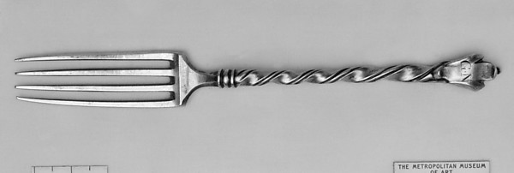
Girolamo Maltraversi (1698–1730) Date: 1700–1730 Culture: Italian, Rome Medium: Silver Dimensions: L. 6 5/8 in. (16.8 cm)
Edited March 5, 2014 by Captain Jim

Capt. Bo of the WTF co.
- Scourge o' the 7 Seas
- Member

- 2,339 posts
- Gender:Male
- Location:Spanish Louisiana - on the river Osage
- Interests:Many and varied.
Posted March 8, 2014 · Report post
Howdy. Some relevant question to ask are; how often there was enough meat available to lower classes, including seamen, to warrant owning/using forks? As far as I have been able to find, most often the little meat available/affordable was stewed with other fodder to make it go farther, and eaten with wooden spoons. Also, how often do you think a pyrat would keep a piece of silverware vs. sell/pawn it for coin. Just "food for thought" if you'll pardon the pun.
Bo

Mission
- Goat Specialist
- Admin

- 5,081 posts
- Gender:Male
- Location:Monroe, MI
- Interests:Scholarly piracy, designing and creating haunted house rooms and props, movies, abstract thinking, abstruse thinking, obstructive thinking, ideating, random thinking, movies, cartoons, movies, movies scores, cycling, world peace and small furry dogs, movies, writing, drawing, personal skills training, gremlins and, of course, lest I forget, movies.
Posted March 9, 2014 · Report post
I also have read that meat was typically cooked in stews on BRN naval vessels. Other foods specified would lend themselves well to spoons - oatmeal, peas and such.
Here's an interesting quote sort of related to this topic from German Johann Dietz (Master Johann Dietz, Surgeon in the Army of the Great Elector and Barber to the Royal Court) from his service on a whaling vessel in the late 17th century:
"Apart from this, there was against the mainmast a great tub, fixed some distance from the deck, containing water that was often stinking and full of little worms, for the general drinking. And, on deck, in open crates was plenty of biscuit; which had to be broken and softened in water, otherwise no one could eat it, so hard and mouldy was it. On at least three days of the week we ate groats, pease, lentils and stockfish, boiled, and pickled beef, pork and mutton, with bacon and a great deal of butter.
When the men were at meals, if it was windy one of them had always to hold the mess-bowl, that is, a great wooden bowl. They all lay flat on the deck, and everyone had to bring his wooden spoon; then they all ate with hand or spoon, and had little need of a knife. When the mess-bowl nearly exhausted, and the man who was holding it because of the rolling of the ship saw that there was just enough for his portion, he cried 'Stop! stop!' -at which they one and all gave over." (Dietz, p. 128)

William Brand
- Mercury Malefactor
- Admin

- 8,884 posts
- Gender:Male
- Location:Logan, Utah
- Interests:My name is William Pace and I live and work as a graphic designer, illustrator and photographer in Northern Utah. I'm married to the lovely Tracy Pace and we have three children. In addition to all things art, I enjoy traveling and meeting new people from every walk of life. I've always been a fan of history, theology, and of course, Pyracy.
http://www.youtube.com/watch?v=PSkt-q-HihQ
Posted March 9, 2014 · Report post
I agree that not all men might have a fork for eating, but the knowledge of which fork is period can be used in ways beyond the portrayal of the common sailor. It would be entertaining to have a common seaman carrying a whole bag of forks for the express purpose of selling them. Indeed, it could be quite humorous to have a crew arguing the very need for forks, when selling them would be more obvious to them. They might even laugh openly at the idea of eating with anything that would strain their food and prove no more useful than a knife.

Capt. Bo of the WTF co.
- Scourge o' the 7 Seas
- Member

- 2,339 posts
- Gender:Male
- Location:Spanish Louisiana - on the river Osage
- Interests:Many and varied.
Posted March 19, 2014 · Report post
That would make a clever scenario indeed! One thing about the Whydah fork though, (I have the catalogue and saw it twice on exhibit) it is a bit larger in overall dimensions than a more modern (19th,20th cent.) standard flatware piece, slightly longer, wider and thicker. I have seen serving forks with flatware sets that are closer to this specimen though. Make sure you carry one in a leather or wooden holder in your gear though, as they tend to poke holes in things you'd rather not have poked otherwise.
Bo

